|  |  |  |
| --- | --- | --- |
| **Name** | **Registration No** | **Marks** |
|  |  |  |
|  |  |  |

**EXPERIMENT # 4**

**Formulation of the Y-bus of given power transmission system using MATLAB/SIMULINK**

**Objectives:**

1. Determining the Ybus matrix of a given power system and performing calculations for system voltages and then verifying them via simulation.
2. Use of Gaussian Elimination for Ybus.

**Lab Tasks:**

1. For the power system shown in the figure; determine the Ybus matrix of the system.
2. Solve for bus voltages using the Ybus matrix: [*V*] = [*Y*]-1 [*I*]
3. Simulate the system in MATLAB / Simulink and verify the bus voltages and compare it.
4. Apply kron reduction to remove Bus 1 and and repeat all above steps

**Diagram:**

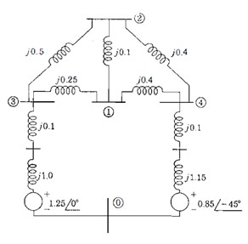

|  |
| --- |
| Y bus= ?  Calculate bus voltages by multiplying Ybus inverse with the current matrix.      **Results of simulation:**  **Results of calculations:** |

**Question(s) / Exercise:**

A. ***Now use Kron Reduction method to remove node 1 from*** the system. Write the equations for the remaining system and repeat all procedure for new circuit?

**Results:**

***AT the end Make table for both circuits compare both Simulink and calculated Values***.

**Conclusion and Learning outcomes:**